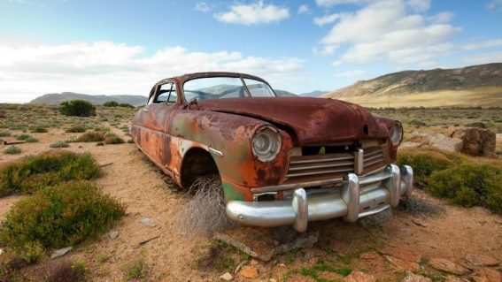**Corrosion**

**Dry Corrosion**

Oxygen is a strong oxidising agent and most metals will undergo direct reaction with oxygen in the air to form a metal oxide. This process is referred to as [dry corrosion](http://lightbook.pearsonplaces.com.au/#sec04282015112836834605).

For example: 2Al(s) + 3O2(g) → 2Al2O3(s) (redox)

In some cases, this corrosion is fast (such as sodium) and in other cases, it is exceptionally slow (such as gold). With many metals, this layer of oxide forms a tough, impervious coating that protects the metal underneath from further contact with oxygen. This is what occurs with the corrosion of aluminium.

Iron is an unusual case, it is much less reactive than sodium or aluminium; the rate of dry corrosion of iron is slow at normal temperatures. However, when iron does corrode, it forms a porous coating that allows the atmosphere to penetrate, and it readily flakes off leaving the metal underneath exposed to further corrosion.

**Wet Corrosion (Rusting) of Iron**

Wet corrosion is common in iron due to the absence of a protective oxide coating. The wet corrosion of iron is called rusting. Rusting is a redox reaction that can be considered a natural example of a galvanic cell.

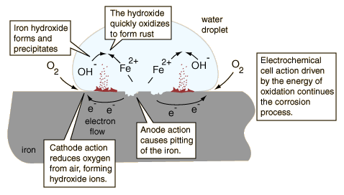

Fe(s) 🡪 Fe2+(aq)+ 2e- E(oxid)= +0.45 V (oxidation)

O2(aq) + 2H2O(l) + 4e- 🡪 4OH-(aq) E(red) = +0.40 V (reduction)

2Fe(s) + O2(aq)+ 2H2O(l) 🡪 2Fe(OH)2(s) emf = +0.85 (redox reaction)

The Fe(OH)2 then undergoes a sequence of reactions.

* The iron (II) hydroxide is oxidised to iron (III) oxide

4Fe(OH)2 (s) + O2(aq) +2H2O(l) 🡪 4Fe(OH)3(s)

* The loose Fe(OH)3(s) can slowly transform into a crystallized form Fe2O3.H2O(s) the familiar red-brown stuff that is called "rust"

The overall equation for the rusting of is therefore:

4Fe(s) + 3O2(g) + xH2O(l) 🡪 2Fe2O3.xH2O(s)

* x is a variable amount of water – extent of hydration, it can be very dry rust or very soggy rust!

**Factors effecting rusting**

Many factors affect the rate of rusting. These include:

* **Temperature:** Increasing temperature increases the rate of rusting.
* **Availability of oxygen:** Changing the level of dissolved oxygen will change the rate of corrosion. Bubbling air (oxygenating) a solution will increase the rate of rusting. Rust inhibitors are often added to radiators to reduce corrosion, many of these are cathodic inhibitors that work by adding a chemical that reacts with the dissolved oxygen to remove it from the solution. For example

**Can iron rust with deoxygenated water?**

No, the reaction is not spontaneous

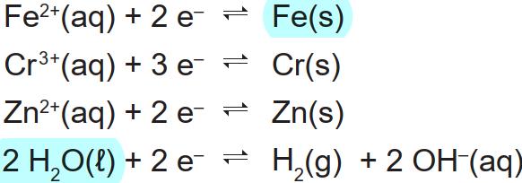

The redox reaction would have a –ve emf

O2 + N2H4 → 2 H2O + N2

Paint works by forming a protecting barrier reducing the metals exposure to oxygen (and water), this is also the case with silver/gold platting and coating in oil. Some chemicals can create a layer of protection under certain conditions (ordinary steel forms a passivating layer in alkali environments, this occurs with steel reinforcing bars in concrete).

* **The availability of water**: Rusting is enhanced in humid environments such and greatly reduced in dry climates such as deserts.
* **The concentration of electrolytes**

The rate of rusting **increases** in the presence of salt because of an increased concentration of dissolved ions. Corrosion is a redox process that involves electron transfer and ion movement. The rate of ion transport can be increased if the conductivity of the aqueous medium increases.

* **Stress (Structural Weaknesses)**

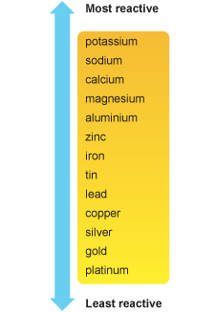If the iron has undergone stress resulting in damage to the lattice, then rusting is increased at the point of weakness. The reason for this increased oxidation at the points of stress is that the atomic structure allows the process to occur more readily.

* **Contact with other metals**

Rusting (corrosion) can be prevented by connecting iron to a more reactive metal (e.g. zinc or magnesium).

* This is referred to as **sacrificial protection or sacrificial anode**, because the more reactive protecting metal is preferentially oxidised away, leaving the protected metal intact.
* Blocks of a more reactive metal like magnesium can be bolted to the steel hulls of ships or underground iron pipes and the more reactive magnesium atoms preferentially lose electrons rather than the iron, i.e. the magnesium stops the iron rusting. So the magnesium corrodes away leaving the iron intact. The block of metal e.g. magnesium must be replaced when the bulk of it has corroded away.
* Sacrificial corrosion is NOT a displacement reaction but it is a preferential oxidation reaction.

If a **less reactive metal** is connected to the iron, it then the **iron rusts preferentially** (try scratching a 'tin' can and leave out in the rain and note the corrosion by the scratch!)

* This is actually the reverse situation to sacrificial corrosion described above!
* Don't buy dented tin cans from supermarkets. You never know what it may taste like! hmm like rust!!!

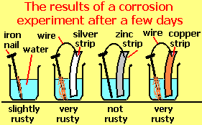You can demonstrate this effect by setting up an experiment by showing a more reactive metal like zinc protects iron wire by sacrificial corrosion, but less reactive metals like silver or copper actually accelerate the rate of corrosion i.e. the iron rusts faster!

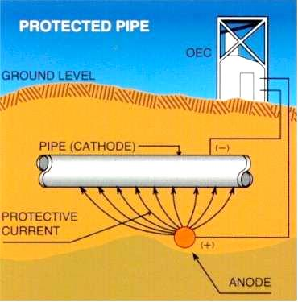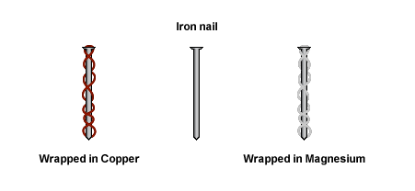

* **Presence of an electrical current**
* A more sophisticated strategy is to maintain a continual negative electrical charge on a metal, so that its dissolution as positive ions is inhibited. Since the entire surface is forced into the cathodic condition, this method is known as cathodic protection. The source of electrons can be an external direct current power supply (commonly used to protect oil pipelines and other buried structures).